# Overview

Upon completion of this chapter, the participant will be able to:

* Differentiate between SharePoint Tasks Lists, Resource Plans, and Schedules.
* Create a SharePoint Tasks List Assignment
* Define the purpose of a project team.
* Build a Resource Plan which allocates resources to a project during a specific timeframe.
* Edit a schedule and assign resources at the task level.
* Explain the purpose of Publishing.
* View cross-project assignments in the enterprise resource pool.

# PWA Resource Management

An important advantage to working with resources in PWA is that it gives you three different options when accounting for resource needs: using SharePoint Tasks Lists, using Resource Plans, or using a Schedule. These three options allow you to create a to-do list type assignment, create a high-level time estimate, or create a detailed task assignment. All options have the capability of illustrating resource capacity in the Resource Center view in PWA.

## Using SharePoint Tasks Lists

One of the quickest resource options is to create a to-do list type assignment. To do this, create a new SharePoint task and choose to assign it to a resource. Assign a resource to a task by typing the name in the Assigned To box.

1. In the Quick Launch menu, click Projects.
2. On the Project Centerpage, click on the name of the SharePoint Task List project.
3. In the Quick Launch menu, click Tasks.

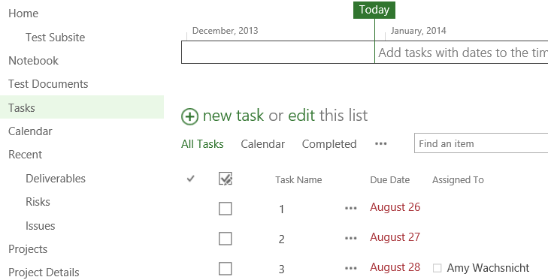

1. SharePoint Task List [SharePoint Task List.TIF]
2. On the Tasks page, click the hyperlink for New Task.

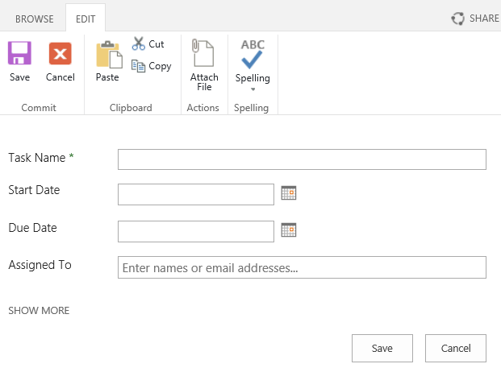

1. New SharePoint Task [New SharePoint Task List.tif]
2. In the Task Name box, enter the name for the task.
3. In the Assigned To box, enter the resource name and then click Save.

Typing the first few letters of an existing resource name should prompt a drop-down list of names that you can select from.

1. When finished with all tasks, in the Quick Launch menu, click Home**.**

Resource utilization can only be modeled for SharePoint task list assignments when a start date and due date are provided for the task.

Warning – The Home button in the Quick Launch returns you to the SharePoint Site home page. Instead, to access other pages, click Project Details to access the PWA Quick Launch.

## Using Resource Plans

You should create a resource plan when you are able to estimate a high-level resource need, but are not able to plan a detailed list of tasks (and perhaps unable to determine who will be working on the project).

A resource plan is a way to plan for resource needs within a specified timeframe on a project, but does not require you to make actual task assignments. This allows you to do long range planning which can help an organization make hiring decisions before the project is fully planned. At any point in a project, you can switch to building a team of resources that will be assigned to tasks.

You can determine when the resource plan is followed by setting the resource utilization options in PWA on the Resource Plan page.

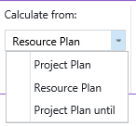

1. Resource Utilization Options on a Resource Plan [Resource Utilization Options on a Resource Plan.tif]

Resource Utilization options:

* Project Plan – follow the project plan for this schedule and ignore the resource plan.
* Resource Plan – follow the resource plan for this schedule and ignore the project plan.
* Project Plan until – follow the project plan until a specified point in time and then follow the resource plan. This is useful for long term planning where immediate details are not known.

### Building a Team in the Resource Plan

The first part of a resource plan is building a team. You will be selecting resources that are available in the enterprise resource pool.

1. In the Quick Launch menu, click Projects.
2. On the Project Center page, click the row selector next to the desired project.

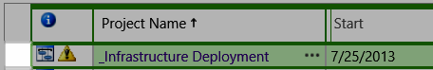

1. Project Center Row Selector [Project Center Row Selector.tif]
2. In the Projects tab, Navigate group, click Resource Plan.
3. In the Plan tab, Resources group, click Build Team.

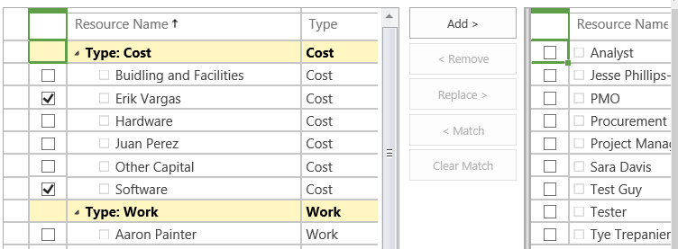

1. Build Team Adding Resources to the Resource Plan [Build Team Adding Resources to the Resource Plan.tif]
2. On the Build Team page, select the checkbox next to the desired resource(s) and click Add.
3. In the Team tab, Team group, click Save and Close.

A best practice is to use generic resource names for resource plans.

### Creating and Publishing a Resource Plan

After a team is created for your resource plan, you need to select the desired options from the ribbon and enter the details for each resource.

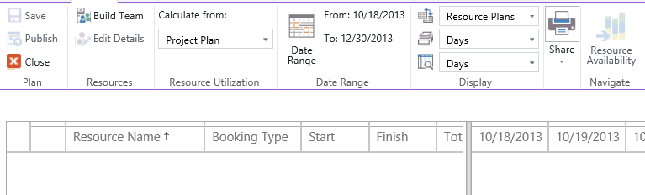

1. Resource Plan Ribbon and Grid [Resource Plan Ribbon and Grid.tif]
2. In the Plan tab, Resource Utilizationgroup, choose the desired option.
3. In the Plan tab, Date Range group, click Date Range and choose the desired options.
4. In the Plan tab, Display group, choose the desired options for Work Units and Timescale.

You can change the options in Work Units on the Resource Plan page if you would like to modify how your resource needs are entered. The options available are hours, days or full-time equivalent.

1. Enter the values in the timescale grid.
2. In the Plan tab, Plan group, click Save.
3. When you are finished with all of your changes, in the Plan tab, Plan group, click Publish and then Close.

Warning – If the Publish button is not available, the specified project already has details in the schedule. You will need to publish the schedule first before publishing the resource plan.

## Using the Schedule

SharePoint projects are simple to do lists. Schedules are detailed tasks with resource assignments. Normally, people transition from a SharePoint task list into a schedule when they are ready for detailed planning.

When you are ready for planning your project in detail, you will need to build a team of resources and assign resources to tasks in the schedule.

Both Enterprise projects and SharePoint Task List projects have dedicated SharePoint sites. The SharePoint Task List is a feature within the SharePoint site for both of these project types. We recommend you explain to your team when they should expect SharePoint task assignments and when they should expect project schedule task assignments.

### Building a Team in the Schedule

You can build a team in PWA by selecting enterprise resources who may be given an assignment on your project or who may need access to project-specific information.

1. In the Quick Launch menu, click Projects.
2. On the Project Centerpage, click on the name of the enterprise project.
3. In the Quick Launch menu for the selected project, click Schedule.
4. In the Task menu, in the Project group, click Edit and then click In Browser.

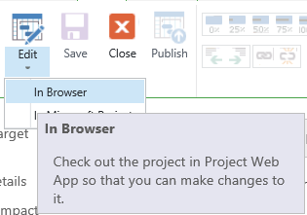

1. Editing a Schedule in PWA [Editing a Schedule in PWA Large.tif]
2. In the Project tab, in the Navigate group, click Build Team.

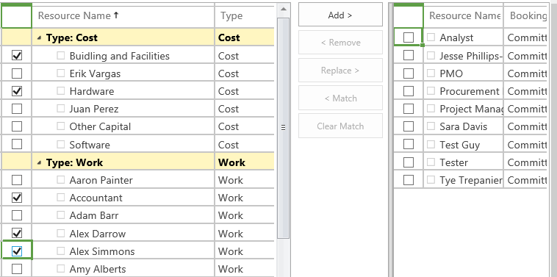

1. Build Team Adding Resources to the Schedule [Build Team Adding Resources to the Schedule.tif]
2. On the Build Team page, select the checkbox next to the desired resource(s) and click Add.
3. In the Team tab, Team group, click Save and Close.

Adding resources to the team is a shortcut to give those team members access to the project’s SharePoint Site which includes features such as: risks, issues, documents, team calendar, and deliverables. These resources do not need to be assigned to a task to view the SharePoint Site.

This function is especially useful when projects are first initiated.

### Assigning Resources with the Resource Names Column

To assign a resource to a task, select the desired resource(s) in the Resource Names column on the PWA schedule page. If the column is not available, you may be in a view that does not support the Resource Names column. There are numerous views that don’t support the Resource Names column. However, the Tasks Summary view displays the Resource Names column by default. Be sure to select a task-based view and adjust the divider bar until you find the column.

1. In a checked out schedule, confirm that you are on the Schedule page in the Quick Launch menu.
2. Navigate to the task that you want to assign a resource.
3. Display the Resource Names column by scrolling the table or dragging the dividing bar in the view.
4. In the row of the desired task, Resource Names column, click the dropdown arrow and click the checkbox next to the desired resource(s) you want to assign to the task.

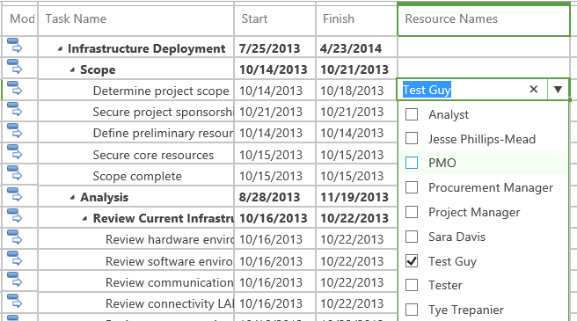

1. Assigning Resources with the Resource Names Column [Assigning Resources with the Resource Names Column.tif]
2. In the Task tab, Project group, click Save.
3. Click Close to check in the project.
4. In the Close dialog box, click OK.

Saving changes without publishing is a great way to build a plan and keep the schedule changes out of public view until the schedule is in a more final state.

Widening the Resource Names column might be needed if the dropdown arrow does not appear when you hover in the cell for the desired task.

### Publishing Task Assignments

The publishing of a schedule does several things:

* It calculates the schedule in PWA which updates Start and Finish dates and redraw the Gantt Chart to display the impact of links.
* It makes schedule changes visible to others and finalizes task assignments so resources can see their tasks in their Timesheet or Tasks page.
* It fully synchronizes information in the database which could be useful if a saved change done in Project Pro is not showing up in PWA.

Publishing a schedule in PWA is slightly different than publishing in Project Pro. The main difference between publishing in PWA over publishing in Project Pro is that the schedule is manually calculated when you publish in PWA.

See what publishing a schedule in Project Pro does in Resource Management in Project Pro.

To publish a schedule in PWA:

1. In the Quick Launch menu, click Projects.
2. On the Project Center page, click on the name of the enterprise project.
3. In the Quick Launch menu for the selected project, click Schedule.
4. In the Task menu, in the Project group, click Edit and then click In Browser.
5. In the Task tab, Project group, click Publish.

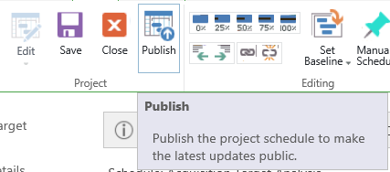

1. Publishing the Schedule in PWA [Publishing the Schedule in PWA Large.tif]
2. Click Close to check in the project.
3. In the Close dialog box, click OK.

## Analyzing Resource Assignments with the Resource Center

Following the creation of a SharePoint Task List assignment, a high-level Resource Plan, or a schedule-based task assignment, you may want to view a summary of all assignments for specific resources. That is the purpose of the Resource Center and it can provide a visual and detailed representation of these assignments.

Your ability to access the Resource Center is controlled by the PWA administrator.

1. In the Quick Launch menu, click Resources.
2. On the Resource Center, select the checkbox next to the desired resource(s).

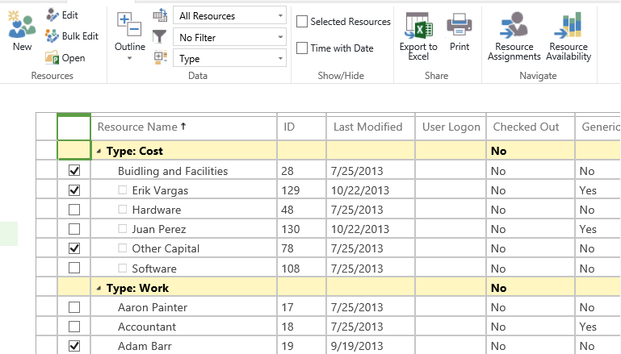

1. Selecting Resources in the Resource Center [Selecting Resources in the Resource Center.tif]
2. In the Resources tab, in the Navigate group, click Resource Availability.
3. In the Availability tab, in the Navigate group, click Resource Center to return to the previous page or click Resource Assignments to drill into the details of task assignments for the selected resources.

No projects are checked out when viewing assignments in the Resource Center; therefore you do not need to check in anything.

The most popular reason why assignments are not visible on the Resource Availability page is because either the Resource Plan or Schedule has yet to be published.

# Key Points to Remember

* PWA offers three different solutions for managing resources: a SharePoint Tasks list, a Resource Plan, and a Schedule with Task Assignments.
* SharePoint Tasks lists are useful as to-do list for small projects.
* Resource Plans are useful for planning high-level resource needs and typically contain generic resources.
* Schedules contain a detailed list of tasks with resource assignments.
* The Resource Center can be used to display assignments and availability across multiple types of projects.
* Resource Plan utilization must be properly set to illustrate allocation using the Resource Center.
* Publishing is required for the Resource Plan or the Schedule to illustrate allocation using the Resource Center.